AFRICAN MARKET OBSERVATORY (AMO): PRICE TRACKER

Welcome to the monthly food price tracker. This is an initiative of the African Market Observatory (AMO) of the Centre for Competition, Regulation and Economic Development, at the University of Johannesburg, and with the support of the Shamba Centre for Food and Climate. It summarises key trends in prices in East and Southern Africa (ESA) for selected staple food products, focusing on highlighted areas.

Online version of the FEBRUARY 2026 PRICE TRACKER

Key Development
- The attack on Iran and blocking of the strait of Hormuz is threatening fertilizer supplies and driving global prices with knock-on effects on food prices.
- In the East and Southern Africa (ESA) region short-term food security conditions remain favourable, as most countries expect substantial harvests in the next two months based on fertilizer purchased in late 2025.
- Animal feed prices in Kenya surge by 45%, despite regional surpluses in 2025 across key inputs such as maize and soybean that could meet Kenyan shortages.
- Kenya is simultaneously suffering from drought and floods as climate change brings more extreme conditions.
- Latest climate forecasts put a 62% probability on El Niño emerging by mid 2026 and persisting through year-end - a shift that could add further pressure to the region.

Maize developments
Figure 1: Maize prices, selected East African countries
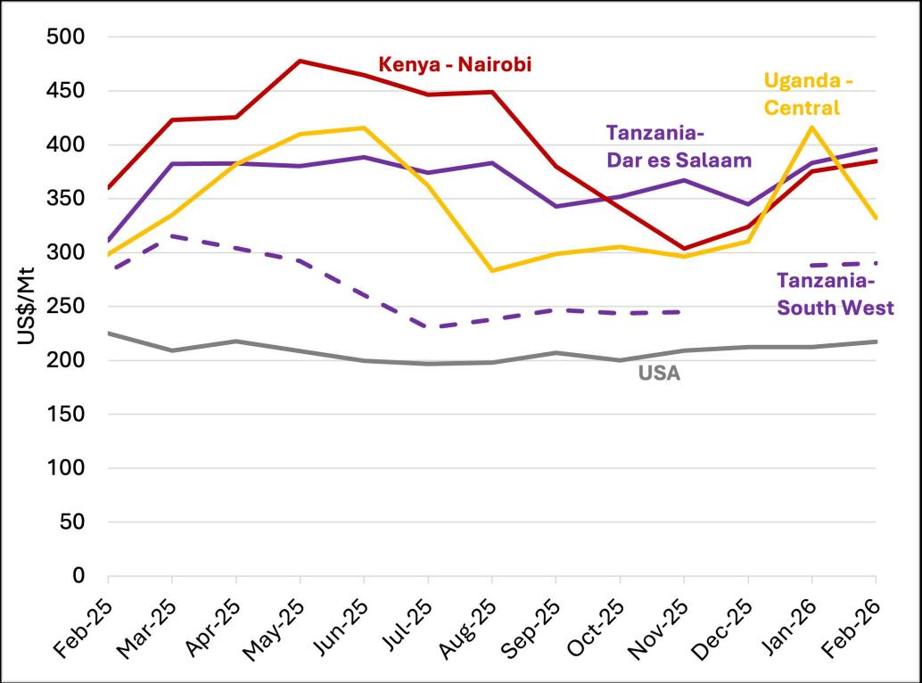
1 - Source: AMO based on price tracker data from multiple sources
- Kenyan maize prices continue to increase reaching US$385/Mt in February, as drought in northern areas persist while there are unseasonal floods in other parts.
- Price increases are also affecting the animal feed industry, amid increasing demand and additional feed manufacturing capacity of 240,000 tonnes.
- Uganda’s maize prices fell below US$350/Mt as markets anticipated increased regional supply, particularly Zambian exports to Kenya, easing demand for Ugandan maize in its key export market.
- Tanzania’s overall fertilizer utilization rose in the 2024/25 planting season pointing a good 2026 maize harvest that could reduce prices from their current levels of US$290/Mt - though delayed rains introduce some uncertainty.

Figure 2: Maize prices, selected Southern African countries
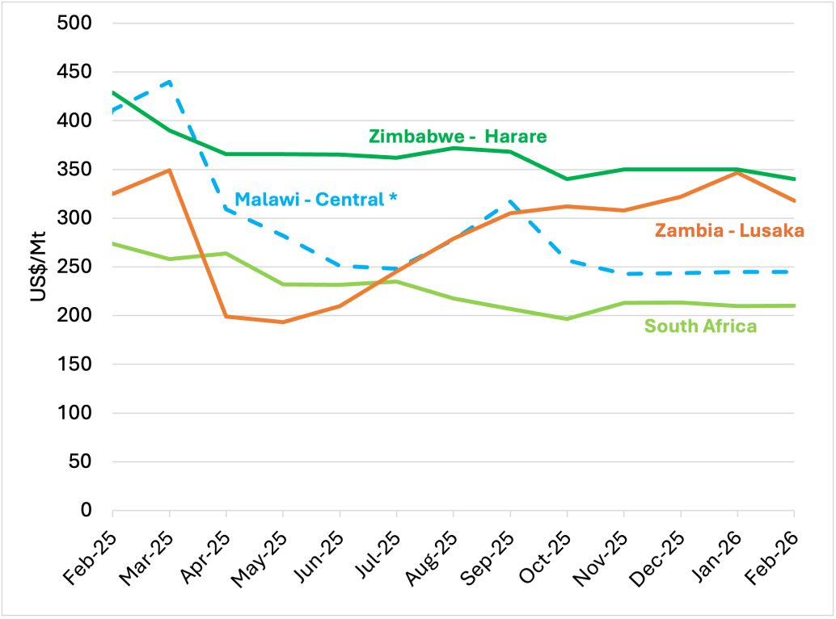
2 - Source: AMO based on price tracker data from multiple sources. *Malawi prices received in local currency and converted using the parallel exchange rate from November 2024, as discussed here.
- Prices in Malawi saw a slight uptick to US$ 235/Mt at the parallel exchange rate. Informal trade across borders continues despite an export ban in place, as traders by-pass prices of MWK840/kg (US$220/Mt at parallel rates) being offered by the National Food Reserve Agency.
- Zimbabwe remains import dependent, with local maize supply constrained ahead of the April marketing season, keeping prices above US$300/Mt.
- Zambia’s prices slightly decreased to US$318/Mt but are still at high levels driven by the government owned Food Reserve Agency (FRA) purchases and demand from East Africa. The FRA is the largest maize buyer in Zambia, its 2025 purchases of over 1.6 million Mt was one of the largest ever, while a further good harvest is expected in the coming months.
- With the Zambian general elections taking place in August 2026, we will monitor its impact on maize prices.

Soybean developments
Figure 3: Soybean prices, selected East African countries
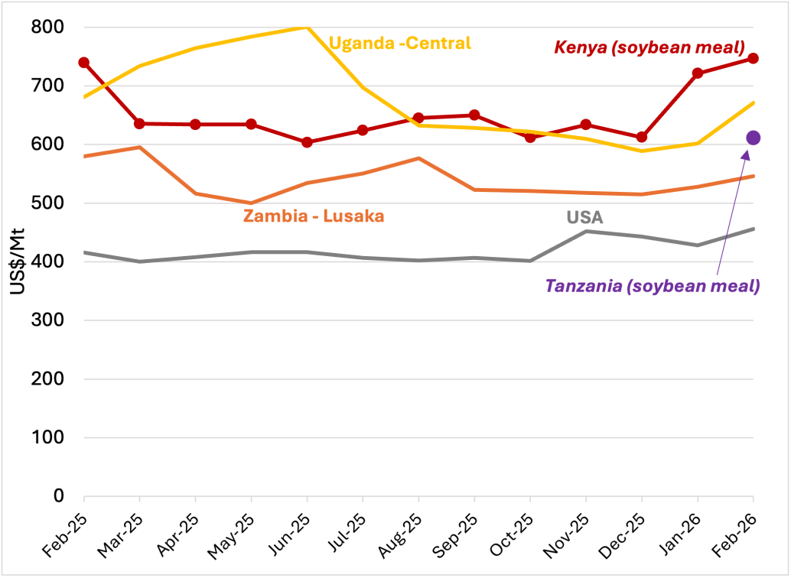
3 - Source: AMO based on price tracker data from multiple sources.
- Kenya soymeal prices have remained at high levels, more than US$200/t above Zambia from where it is sourced, and 60% higher than international prices.
- Soybean prices in Uganda have increased towards US$700/Mt as stocks tighten.
Figure 4: Soybean prices, Southern African countries
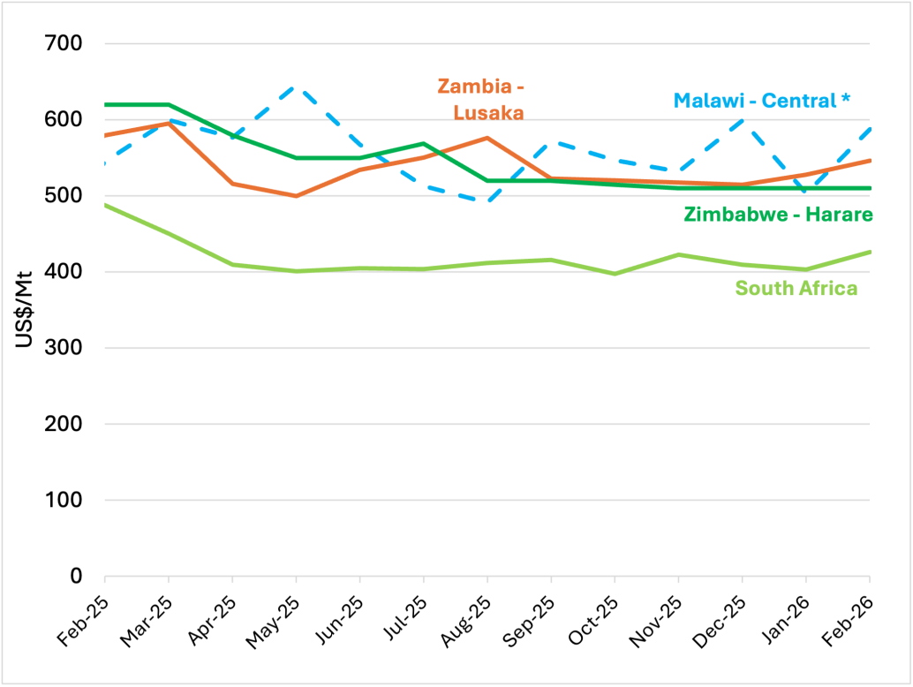
4 - Source: AMO based on price tracker data from multiple sources. *Malawi prices received in local currency and converted using the parallel exchange rate from November 2024, as discussed here.
- Since the end of last year, Zimbabwe’s soybean prices have remained stable at around US$510/tonne, with domestic demand met by imports from South Africa.
- Malawi soybean prices continue to fluctuate with February prices reaching just over US$580/Mt. Sources reference reduction in stock availability as the harvest is expected to begin in the last week of March 2026. [1]
- Zambia soybeans prices slightly increased to US$546/Mt ahead of the harvest in April 2026, which is expected to improve over previous years.
[1] Interview with AMO market participant in Malawi, 16 March 2026.

Egg consumer prices
Figure 5: Egg consumer prices (US$/tray of 30 eggs), selected ESA countries
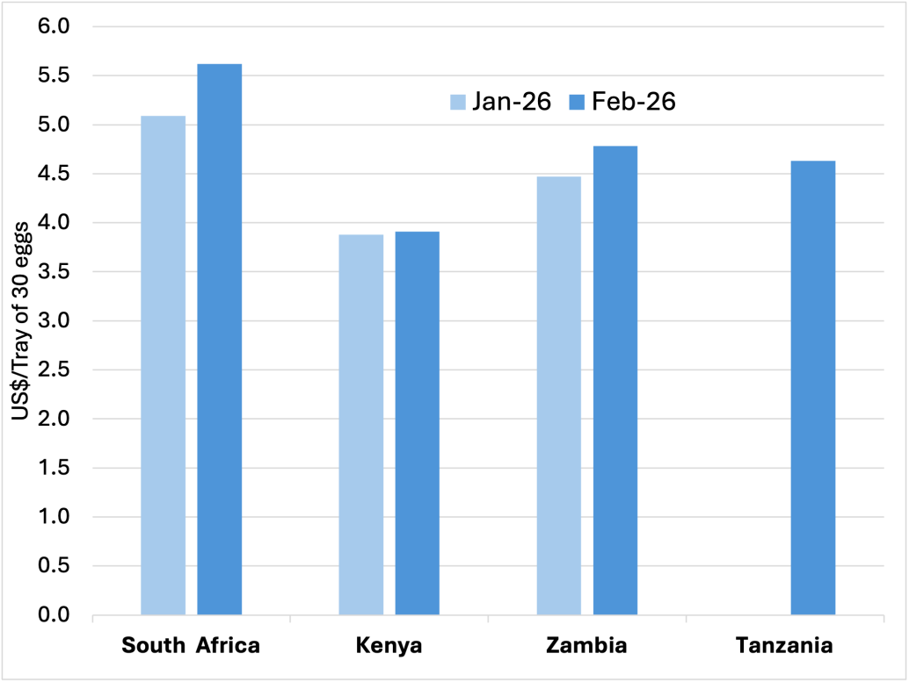
5 - Source: AMO, from major supermarkets for large size eggs where available, Zambia Competition and Consumer Protection Commission.
- South African eggs were the most expensive in the region, with a retail price of around US$5 per tray of 30 eggs, while Kenyan egg prices were the lowest and remained stable.
- Some price differences may be driven by a combination of factors, including egg size, brand, and variations in retail and distribution costs across countries.

Rice Developments
Figure 6: Rice prices, selected ESA countries
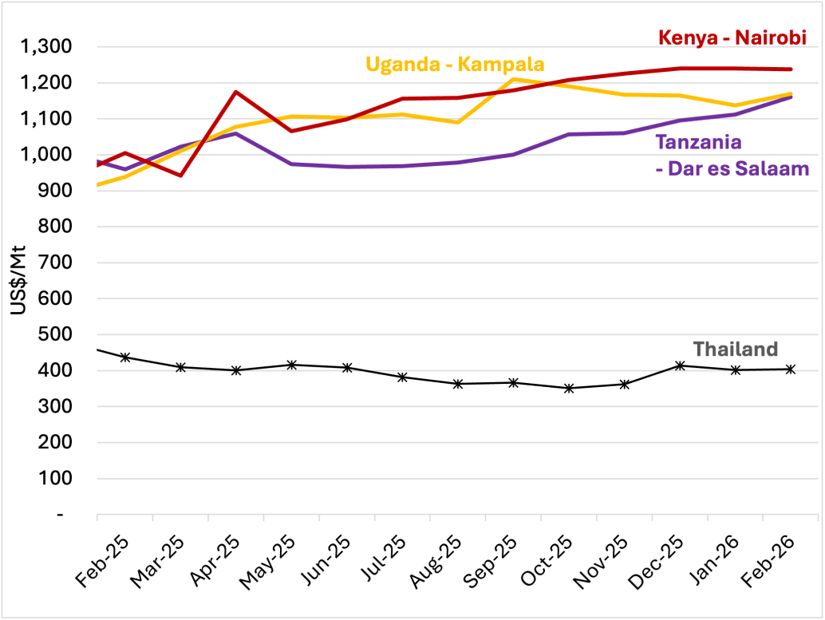
6 - Source: AMO based on price tracker data from multiple sources, Thailand price is from the World Bank.
- Rice prices in East Africa remain extremely high
- Uganda and Tanzania are trading at similar levels, both just under US$1,200/Mt, while Kenya trades even higher

Fertilizer developments
Figure 7: Urea Fertilizer prices, selected ESA countries
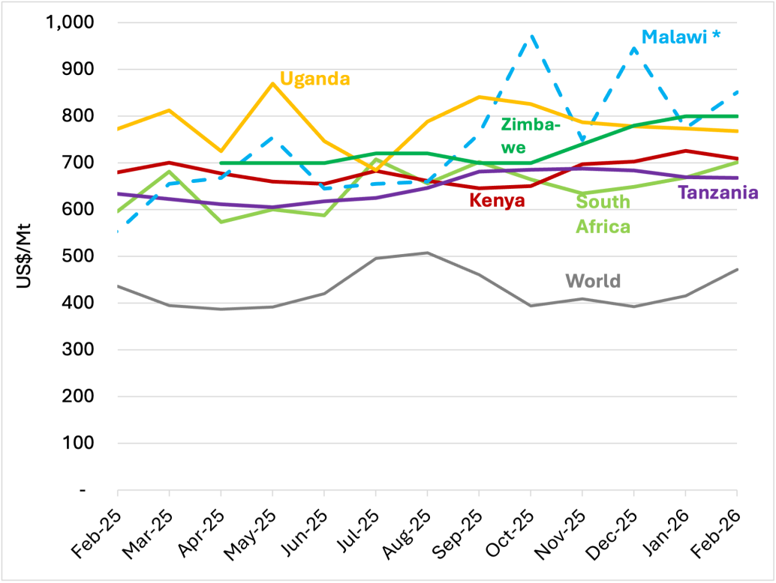
7 - Source: AMO own calculations based on multiple sources; World Bank (world price) and Grain SA (South Africa). Kenya based on retail prices from Africafert and KAMIS. Tanzania regulator (last price adjustment in September 2025- other changes are forex related). Malawi* prices received in local currency and converted using the parallel exchange rate from November 2024, as discussed here.
- Fertilizer prices in the region are consistently above the global benchmark and prices in Zimbabwe remain almost the most expensive once they had surpassed Uganda at the end of last year.
- Tanzania’s regulated retail prices before subsidies at US$668/Mt are slightly less than South African prices at US$701/Mt. Insights from market participants indicate that backlogs in subsidy payments to importers have resulted in decreased volumes by some importers although overall fertilizer utilization in Tanzania is on the increase.

Annexure Malawi prices - official vs parallel exchange rate
Given the divergence of the official and parallel exchange rates in Malawi we use the parallel exchange rate from November 2024 for the conversion of local prices into US$. See discussion here.
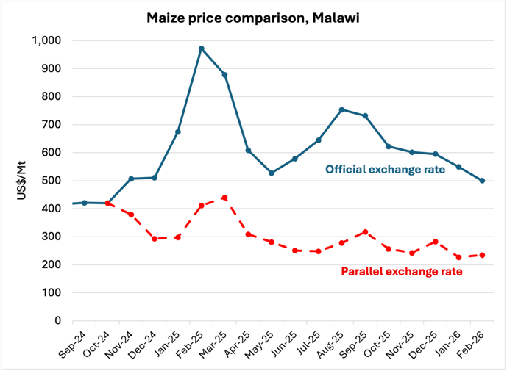
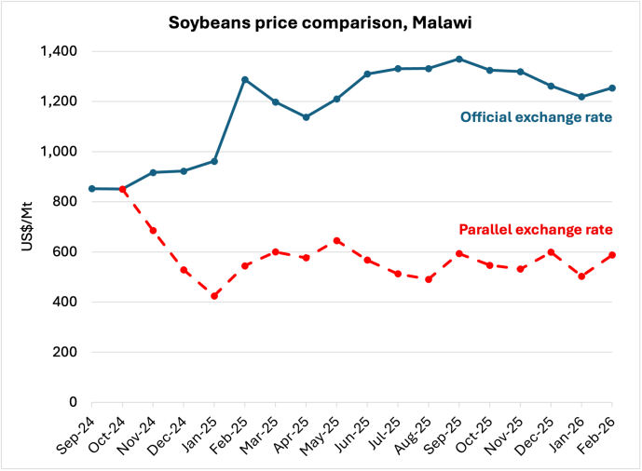
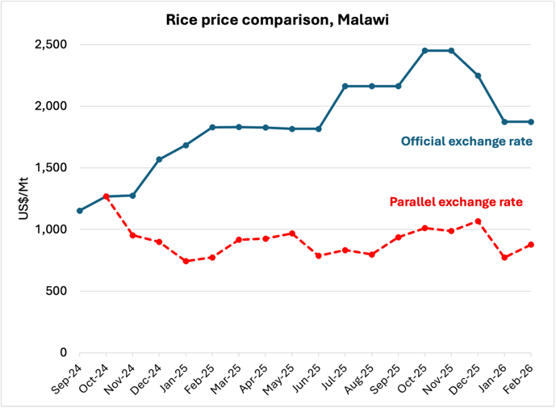
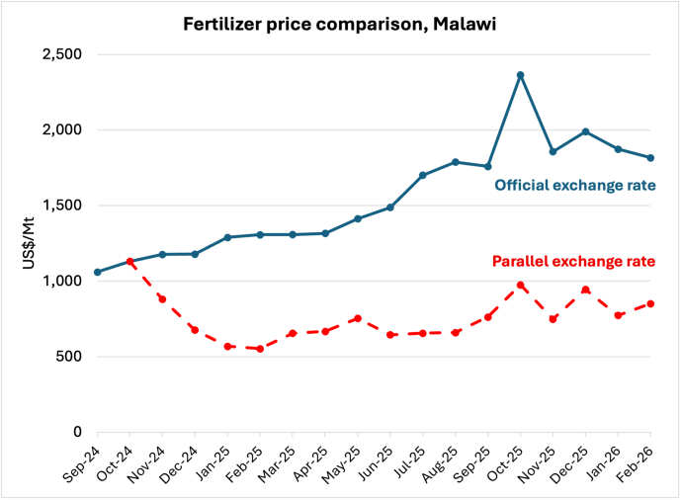

African Market Observatory (AMO)

The AMO is an initiative by the Centre for Competition, Regulation and Economic Development (CCRED) at the University of Johannesburg

Find us
👉🏾 www.competition.org.za/africanmarketobservatory
👉🏾 info.amo@uj.ac.za
👉🏾 CCRED
👉🏾 @CCRED_UJ
📥 The Price Tracker in your inbox: AMO-PT-SignUp

The AMO is supported by COMESA Competition Commission, the Shamba Centre for Food & Climate, the International Trade Centre and the African Climate Foundation


